**📄 1: What is Agile?**

🌟 Definition

Agile is a **project management philosophy** and **software development methodology** that emphasizes:

* **Iterative development**
* **Customer collaboration**
* **Flexibility to change**
* **Continuous delivery of valuable software**

🧭 Core Principles (from the Agile Manifesto)

* **Individuals and interactions** over processes and tools
* **Working software** over comprehensive documentation
* **Customer collaboration** over contract negotiation
* **Responding to change** over following a plan

**🔁 Agile Lifecycle**

Agile projects are broken into **small cycles** called iterations or sprints (typically 1–4 weeks). Each cycle includes:

* Planning
* Development
* Testing
* Review
* Retrospective

✅ Benefits

* Faster delivery of features
* Improved customer satisfaction
* Better adaptability to changing requirements
* Enhanced team collaboration

**📄 2: What is Scrum?**

🧩 Definition

Scrum is a **framework within Agile** used to manage complex projects. It provides a structured way for teams to work together and deliver high-quality products incrementally.

🏗️ Scrum Framework Components

* **Roles**: Product Owner, Scrum Master, Development Team
* **Artifacts**: Product Backlog, Sprint Backlog, Increment
* **Events**:
* **Sprint**: Time-boxed iteration (usually 2–4 weeks)
* **Sprint Planning**: Define sprint goals and backlog items
* **Daily Scrum**: 15-minute stand-up meeting
* **Sprint Review**: Demonstrate completed work
* **Sprint Retrospective**: Reflect and improve

🔄 Scrum Cycle

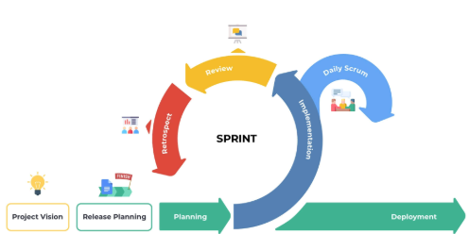🎯 Key Values

* Commitment
* Courage
* Focus
* Openness
* Respect

**📄 3: Scrum Roles Explained**

👤 Product Owner

The Product Owner is responsible for **maximizing the value** of the product resulting from the work of the Scrum Team.

Responsibilities:

* Define and prioritize items in the **Product Backlog**
* Ensure the team understands the **business goals**
* Make decisions about **features and delivery**
* Act as the **voice of the customer**

Skills:

* Strong domain knowledge
* Decision-making authority
* Stakeholder communication

🧑‍🏫 Scrum Master

The Scrum Master is a **servant-leader** who helps the team follow Scrum practices and removes obstacles.

Responsibilities:

* Facilitate Scrum events (Daily Scrum, Planning, Review, Retrospective)
* Coach the team on Agile principles
* Remove impediments to progress
* Shield the team from external disruptions

Skills:

* Deep understanding of Scrum
* Conflict resolution
* Coaching and mentoring
* Process improvement

Would you like this formatted into a downloadable document or want help turning it into a presentation or GitHub README?